Bahria University,

Karachi Campus



LAB EXPERIMENT NO.

05

LIST OF TASKS

|  |  |
| --- | --- |
| TASK NO | OBJECTIVE |
|  | Connect 4 switches A, B, C and D, all switches must be password protected (encrypted password) and apply the following configuration, show network topology and configuration in your lab task. |
| 1 | Switch B, C, D must be connected to switch A |
| 2 | Switch B with VLAN name Faculty & Students having 5 logical ports each |
| 3 | Switch C with VLAN name Management having 3 logical ports |
| 4 | Switch D with VLAN name SRC & NCMPR having 3 logical ports each |
| 5 | Any PC of VLAN Faculty from any PC connected to switch D VLAN SRC (Ping) |
| 6 | Any PC of VLAN student from any PC connected to switch D VLAN SRC (Failed) |
| 7 | Any PC of VLAN Student from any PC connected to switch C VLAN Management (Ping) |
| 8 | Any PC of VLAN Management from same VLAN (ping) |
| 9 | VLAN NCMPR from VLAN Student (Failed) |
| 10 | Any PC of VLAN Faculty from any PC connected to switch D VLAN SRC (Ping) |

Submitted On:

25-OCT-2023

(Date: DD/MM/YYYY)

**LAB 05 VIRTUAL PRIVATE NETWORK**

**Connect 4 switches A, B, C and D, all switches must be password protected (encrypted password) and apply the following configuration, show network topology and configuration in your lab task.**

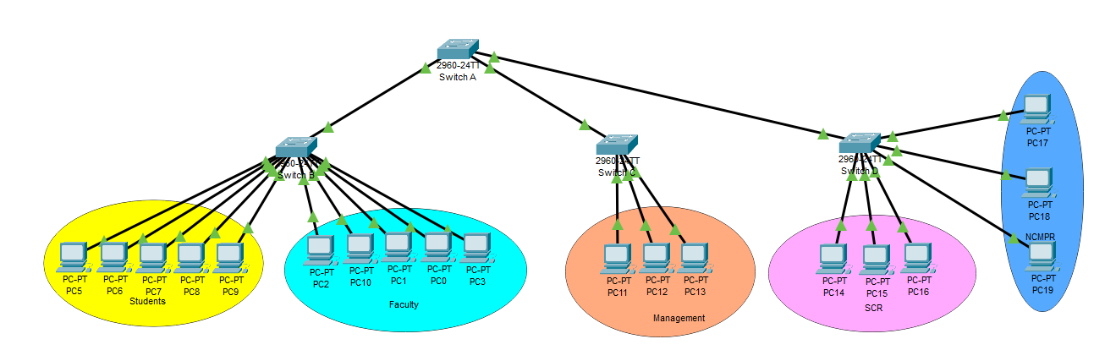

**SWITCH 1 Password Encryption**

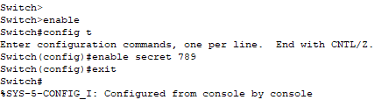

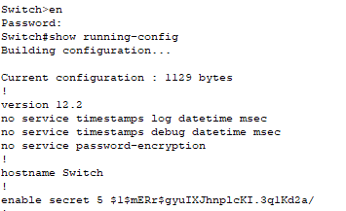

**SWITCH 4 Password Encryption**

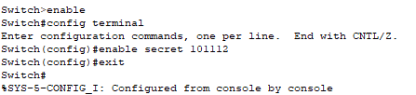

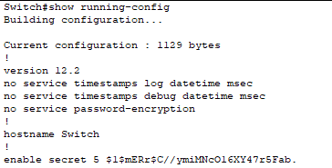

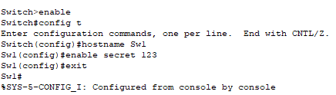

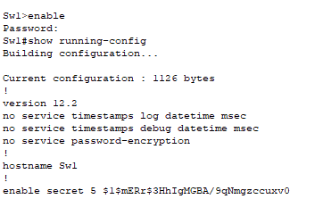

**SWITCH 2 Password Encryption**

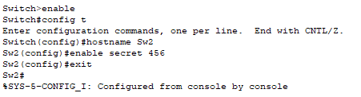

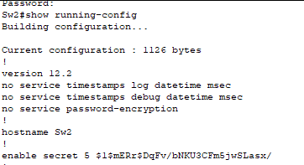

**SWITCH 3 Password Encryption**

**Switch B with VLAN name Faculty & Students having 5 logical ports each**

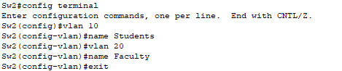

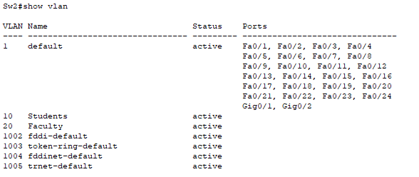

**Switch C with VLAN name Management having 3 logical ports**

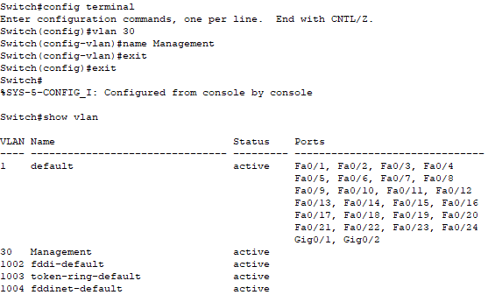

**Switch D with VLAN name SRC & NCMPR having 3 logical ports each**

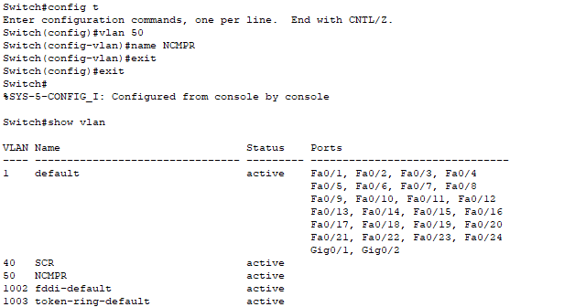

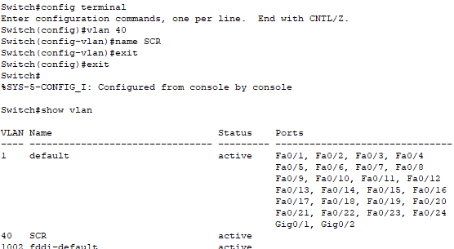

**TRUNK COMMANDS IN SWITCH A**

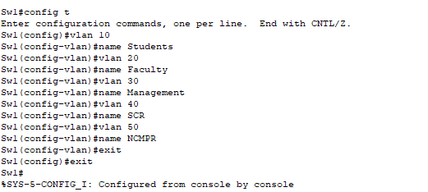

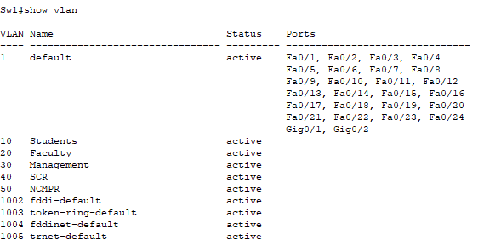

Any PC of VLAN Faculty from any PC connected to switch D VLAN SRC (Ping)

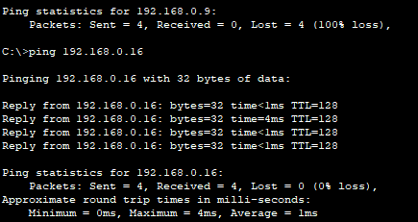

Any PC of VLAN student from any PC connected to switch D VLAN SRC (Failed)

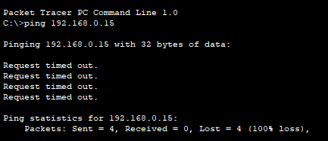

Any PC of VLAN Student from any PC connected to switch C VLAN Management (Ping)

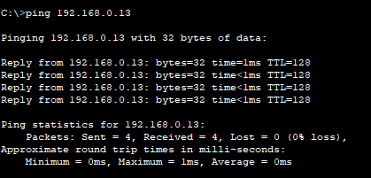

Any PC of VLAN Management from same VLAN (ping)

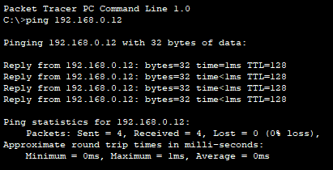

VLAN NCMPR from VLAN Student (Failed)

